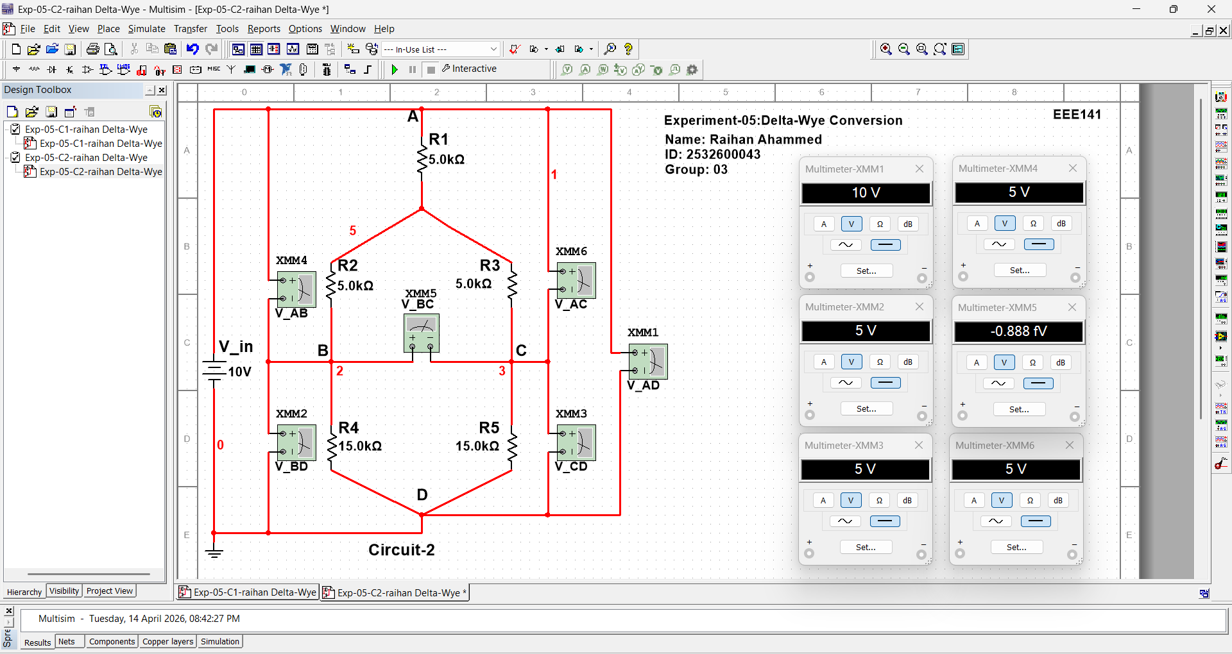
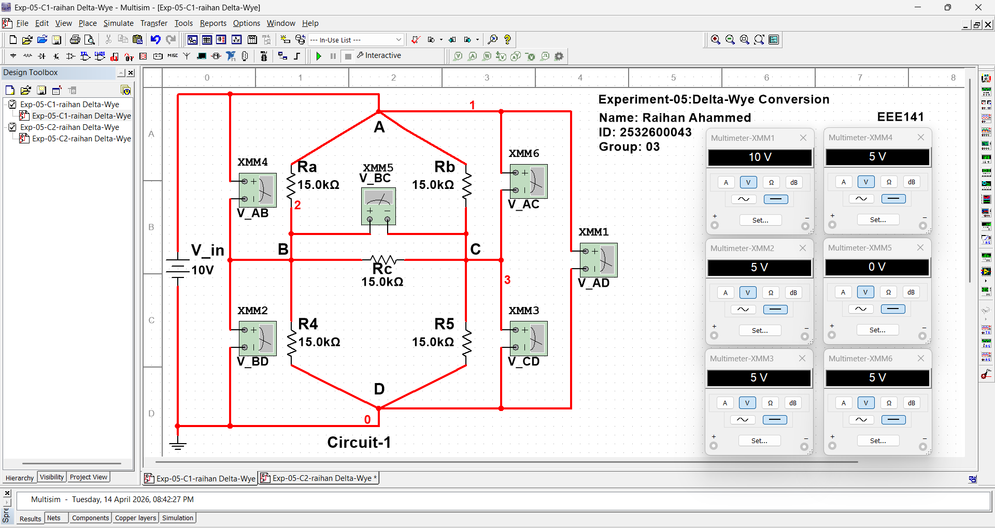
Delta-( Δ ) Configuration
Wye-( Υ ) Configuration

